

Meter Xperts Case Study

Leading Smart Metering Provider. Capture, Analyse, Report…

_________________________
PROJECT INFORMATION
Construction: Business Premises
Type: Commercial / Industrial
Partners:
Planet A
Date completed: 2023
Produced by: Madison Gallagher
_________________________
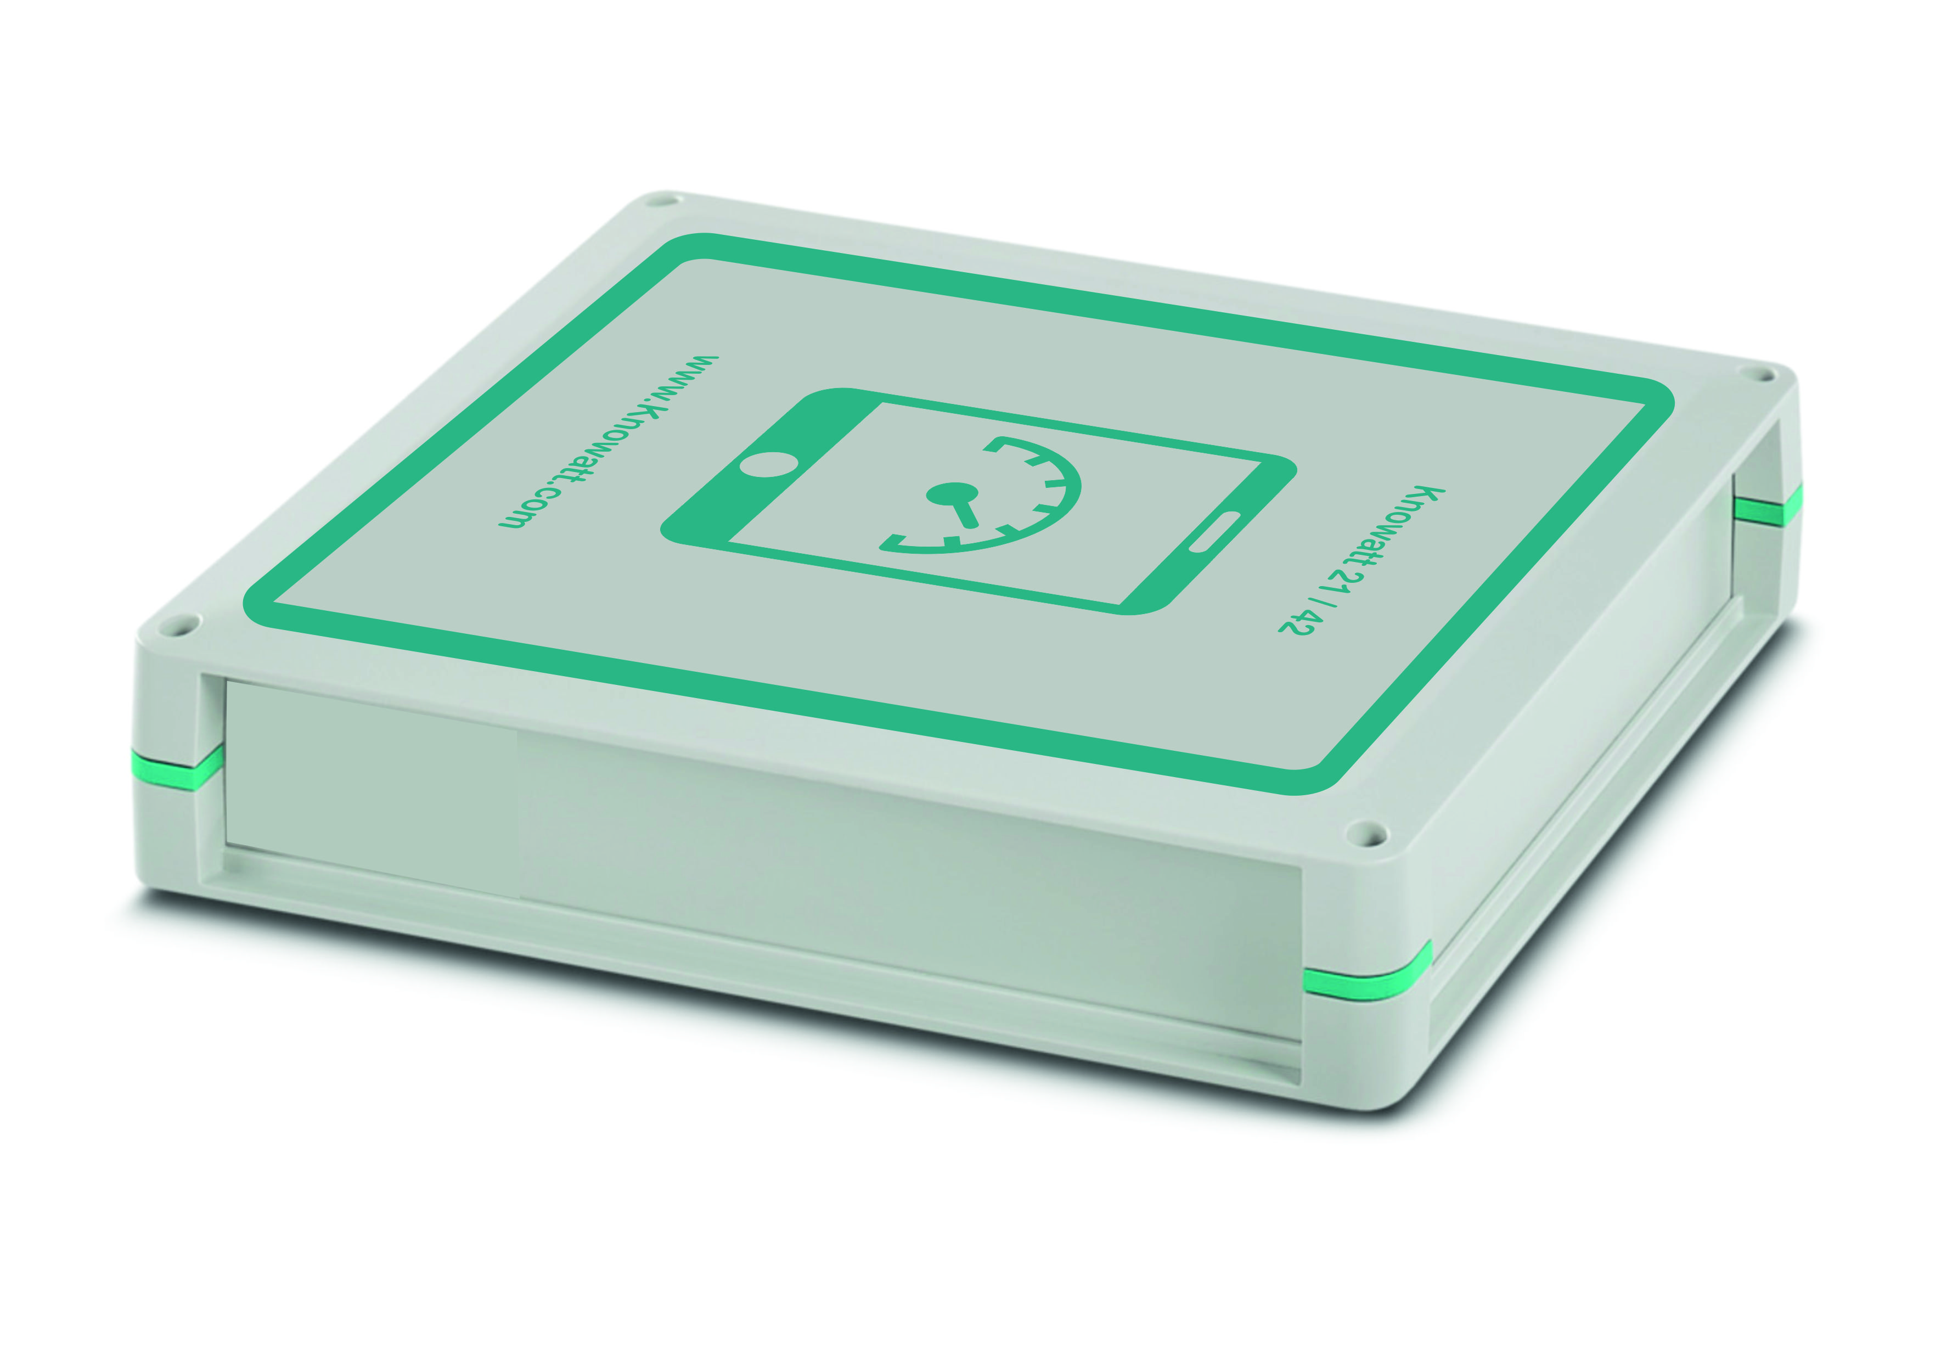

Meter Xperts’ smart metering projects range from just a few meters to large campus sized solutions. With partnerships including Knowatt, A Bespoke Hardware solution can be designed that meets your needs and budget.
Being technology agnostic, priding ourselves on wrapping our services around a clients existing infrastructure. We specialise in installing metering systems for Power Management, Energy Management and Tenant billing across all utilities.
Knowatt Solutions provide unlimited circuit and utility monitoring with the ability to integrate into existing BMS systems or simply monitoring, collecting and transmitting data, using a number of methods depending on site requirement.
Allowing Meter Xperts to have a turnkey solution that meets any existing or tailored site requirements from a single source provider with proven unrivalled accuracy.
Knowatt solutions allow end-users to change their energy suppliers without the worry of any re-integration. Our customers can send data to as many energy management systems and platforms as they wish, with is no loss of data and all historical data can be loaded in minutes.

