

Whitwam Case Study

Leading Supplier of AV and control equipment in the most prestige locations…

_________________________
PROJECT INFORMATION
Construction: Listed buildings
Type: monarchy and churches
Partners:
Whitwam
Date completed: 2000 ~
Produced by: Madison Gallagher
_________________________
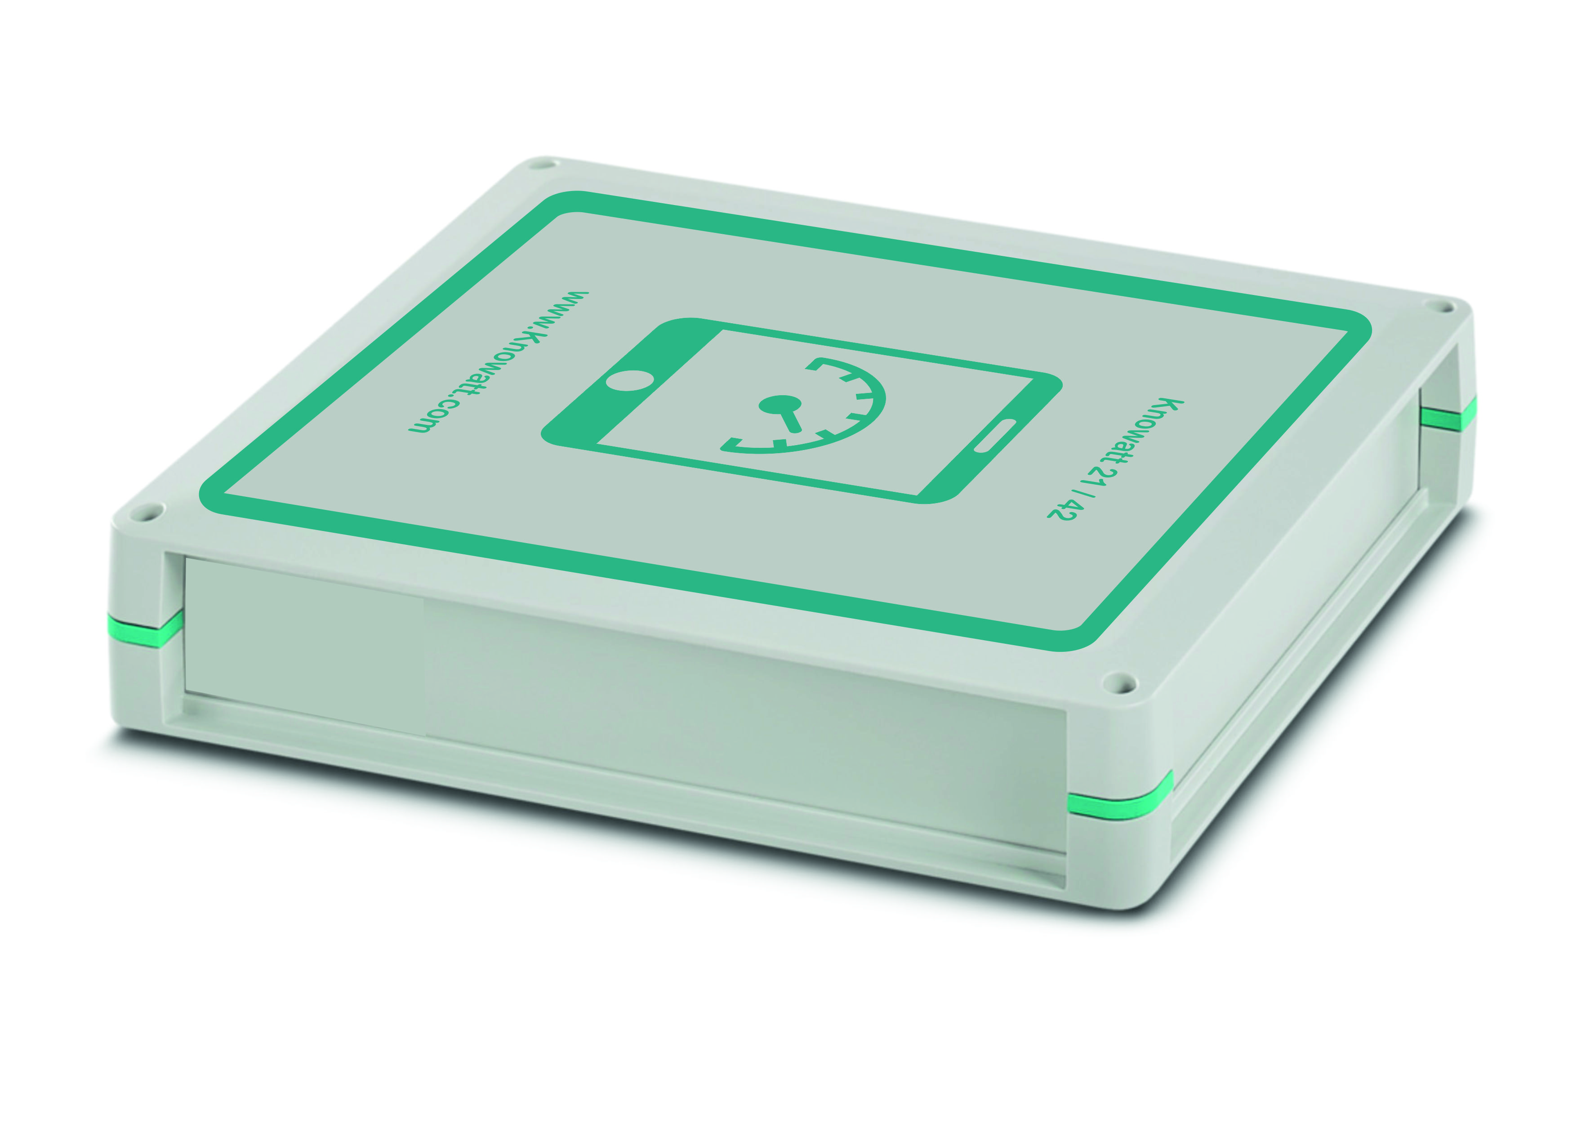

Whitwam of Winchester are a specialist AV company, who offers permanent architectural and commercial audio visual installations. Traditionally, Whitwam has been the chosen supplier within historic and unusual environments, such as Windsor Castle and Westminster Abbey. However, they have also worked in many modern buildings and institutions. Their client list includes: Nexen, Royal Mail, Durham Cathedral, he Royal Society, St. George's Chapel, Windsor
Although they have decades of experience in this field, they offer the very latest technology and creative ideas, with an enormous store of specialised knowledge and practicality.

Knowatt have worked with Whitwam on a number of different projects including London Gatwick, Westminster Cathedral, Hampshire Firestation and The Royal Greenjackets museum.

Where Whitwam are specialists in AV they require the expertise of Knowatts to create and integrate control equipment for the PA and engineering side of complex systems.

