

Planet A Energy Case Study

Conceive, Develop, and Implement solutions for Energy Users…

_________________________
PROJECT INFORMATION
Construction: Business Premises
Type: Commercial / Industrial
Partners:
Planet A
Date completed: 2023
Produced by: Madison Gallagher
_________________________
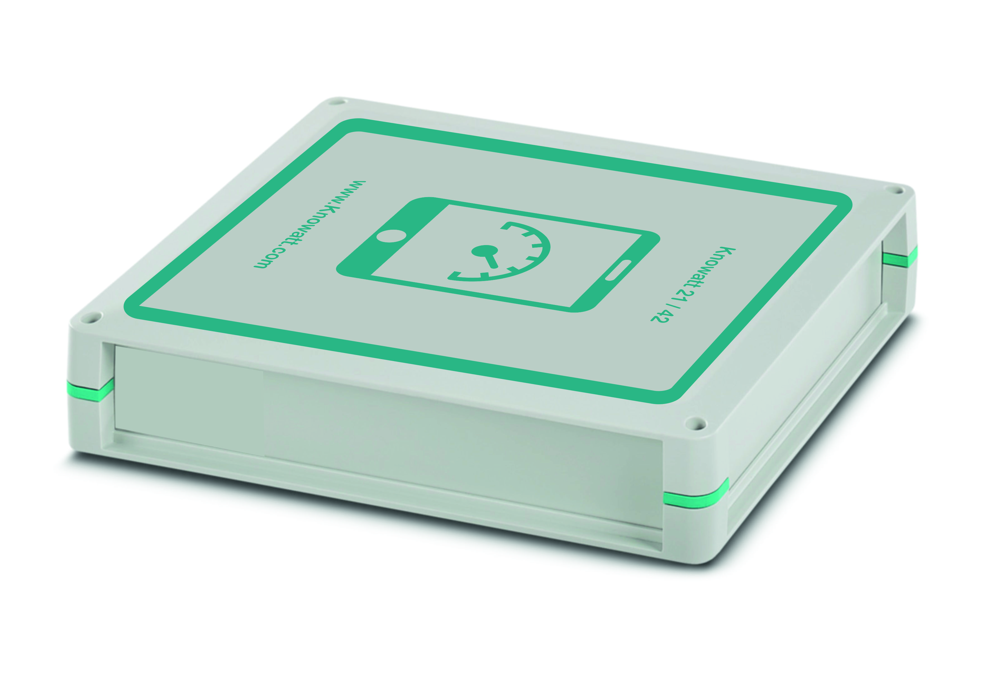

Planet A experts provide a business case for technical challenges whilst offering targeted expertise to bring the right combination of energy solutions with maximum impact.
Understanding commercial business, their models aim to increase a company’s bottom line but doing this in a sustainable, ethical way with the ability of lowering green-house gas emissions.
‘Our Goal’ - To bring the UK through this decade to meet climate change targets by 2030.

Project 1st Phase - A study of energy demand and use. Using the Knowatt solution to collect the sites data, We analyse how much electricity, heat and water is consumed through your business and suggest ways to reduce and improve processes. Resource assessment looks at how much energy can be produced on site using renewable and low carbon technologies, how much it will cost, and how quickly you can offset those costs.

The Aim:- Reduce the energy demand to save money. This can be done by improving functionality to reduce wasted heat and monitoring your energy demand to understand exactly where it is spent. The User Friendly GUI enables sites to monitor, understand and see changes in-house.

The Solution:- We offer an objective view on what technology is best suited to replace fossil fuels at your premises. Not only can we advise, but we offer detailed cashflow models, quotes from local and trusted suppliers and project management all the way through to commissioning. We’ll have you up and running in no time.
We offer targeted energy strategy and management unique to your business.

