

Brook Green Case Study

High Pressure, High Demand

_________________________
PROJECT INFORMATION
Construction: Business Centre
Type: Trading Floor
Partners:
Brook Green Supply
Date completed: 2022
Produced by: Madison Gallagher
_________________________
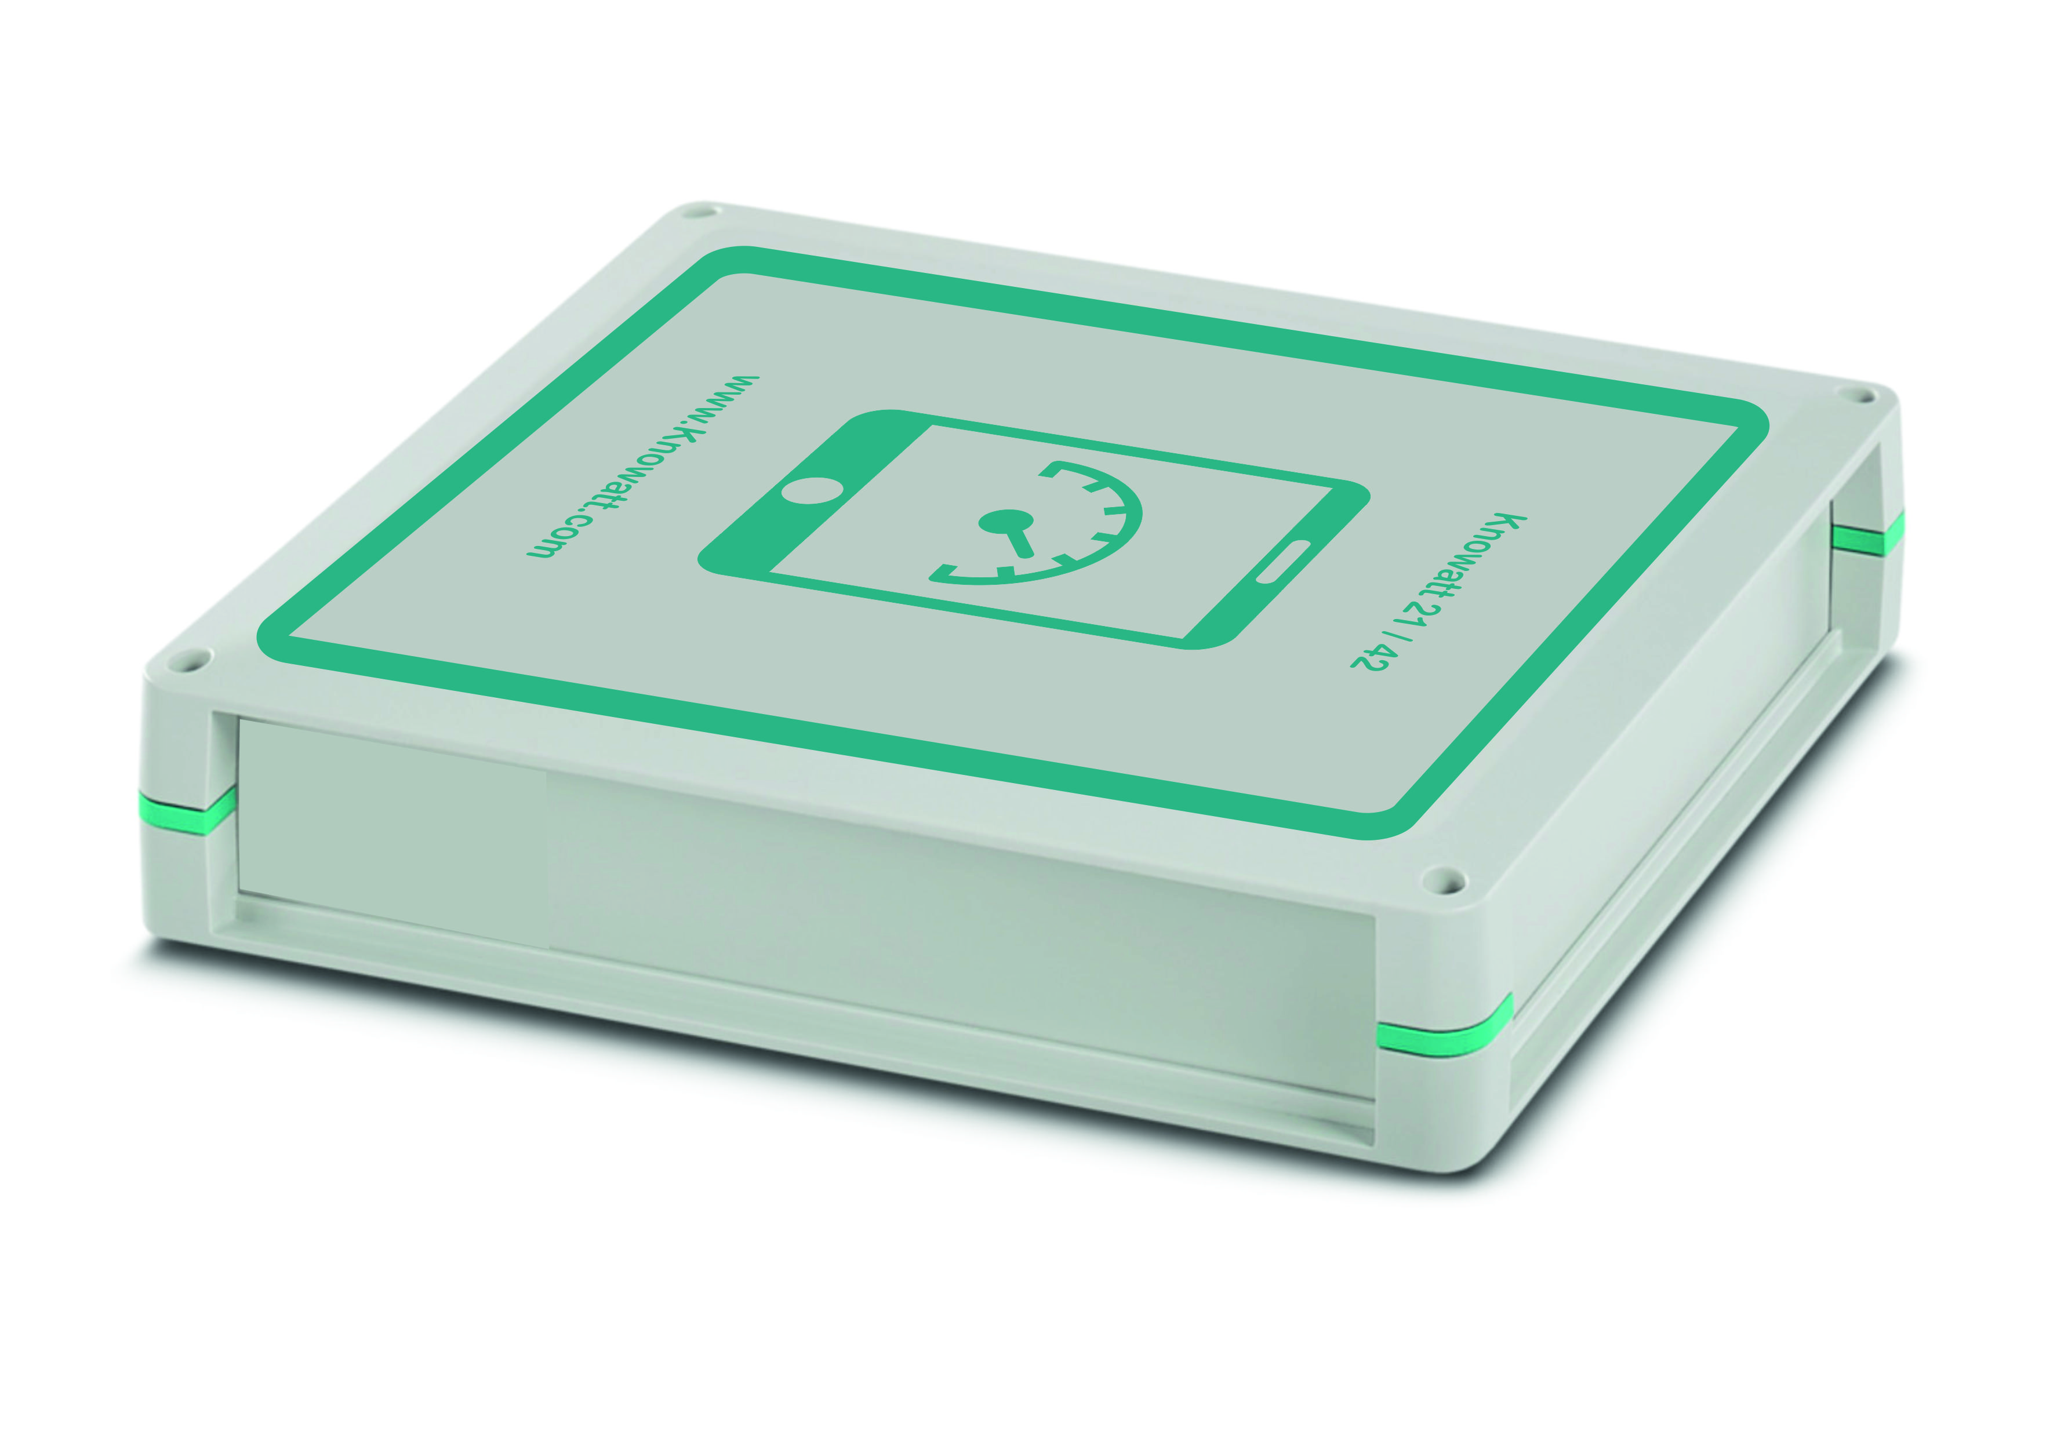

Brook Green Supply is made up of an experienced team with a broad range of backgrounds from within and outside the energy markets.
Committed to delivering the best possible supply solutions for today, whilst also building a leading and innovative energy platform to help our customers meet future challenges that go beyond traditional supply.
Focusing on providing large and complex energy users with the best-in-class product, market access and operation process.

Partnering with Consumers, Generators and Technology providers to develop new structures and products that can reduce risk and accelerate the energy transition. With the focus to Reduce energy and maximize savings.

The solution Knowatt provides.

Brook Green enlisted the solution provided by Knowatt to monitor their own usage across their Trading Centre.
A large sales focus behind Brook Green is proving that changes can be made, and reduction of usage is possible. Savings can be derived not only from reduction but also having the correct tariff and supply from the correct company.

To show true transparency to their customers, Brook Green required a solution that could monitor their usage whilst being able to maintain supply uptime, due to the trading business hours.

Knowatt was able to be installed and provide detailed insight as to where on the trading floor Energy was being consumed and where energy can be saved by making simple automated changes to the business itself.
Linking data from other Light, Humidity and Temperature sensors, it was easily established where changes to infrastructure and insulation can be made through out areas to maximize heating requirements throughout the site and save money for heating areas unnecessarily.

The Knowatt system was able to provide detailed data, showing not only the entire site’s consumption but invaluable circuit data outlining the exact usage through out every area of the building at every minute of the day.
Using this information, Brook Green was advised how they were able to make savings into the £1000’s each year and openly advise and prove to customers that they too can reduce and save.

