

British Gas Case Study

Largest UK Energy Supplier Leads the Revolution…

_________________________
PROJECT INFORMATION
Construction: Housing Projects
Type: Domestic
Partners:
British Gas
Passiv Systems
EA Technology
Date completed: 2016
Produced by: Madison Gallagher
_________________________
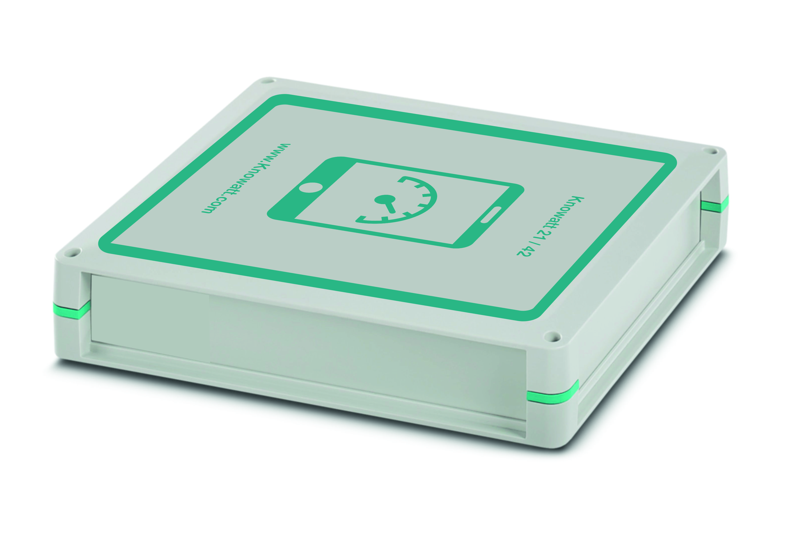

The Customer Led Network Revolution project will produce knowledge to help electricity customers across the country reduce both their energy costs and their carbon emissions. If, as a result, it speeds up the installation of low-carbon technologies by just one year, it could save the country around £8 billion in energy costs, and 43 million tonnes of
CO₂ emissions.

Phil Jones, President of Northern Powergrid says:
“This is a project whose time has come. What is being contemplated in the electricity industry is nothing short of a revolution. It used to be that all the power came from a few power stations to every property – and all the energy flowed one way. The prospect of smarter networks opens up a whole new set of possibilities - customers can generate their own energy and use home-based technology to regulate how and when they use it.”

The solution Knowatt provides.
The UK’s biggest smart grid project is in the forefront of the move towards a low carbon economy. 14,000 homes and businesses, mostly in the North East and Yorkshire, will be involved in this innovative £54 million project, helping us to find ways for customers to reduce both their energy costs and carbon emissions in the years to come.
- Knowatt – Energy division provided the ‘Smart’ individual circuit power meters.

- Knowatt was chosen by EA Technology & British Gas to supply the multi-channel monitors for the CLNR project.

- The Knowatt 24 previously named ‘Polymeter’ range; Polymeter16 for domestic & 24 for 3 phase industrial measure true power including power factor, frequency, Amps & Wh.

