

Gatwick International Airport Case Study

London’s Second Largest/ Busiest International Airport…

_________________________
PROJECT INFORMATION
Construction: Airport
Type: Large International
Partners:
Gatwick International
ASL
Audix
Date completed: On-going
Produced by: Madison Gallagher
_________________________
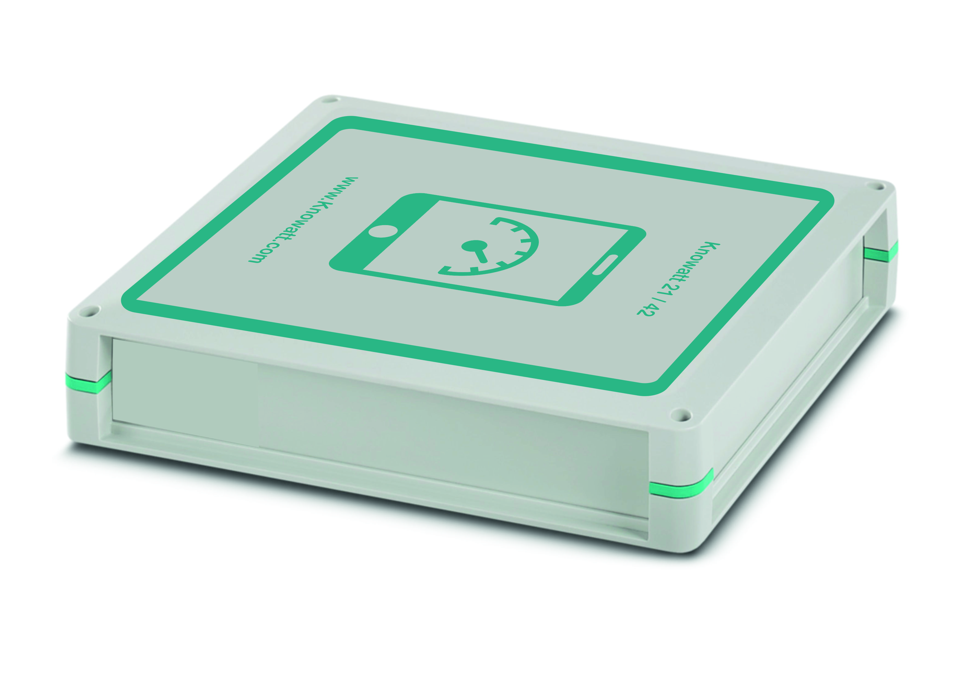

Phonetica’s association with Gatwick goes back to 1983, when we supplied a ‘Fixed Ground Power Monitoring System’. The FGPMS monitors the power consumed by aircraft whilst on the ground, using the high cost 200Hz supplies required by aircraft. The FGPMS is both a fiscal billing and a maintenance system.
Since then, we have supplied a number of systems including the Information Desk system, known as ‘The Phonetica’, and a number of automated PA controllers. In 2008, we installed a 10Gig fibre backbone as part of the PA extension between the North & South terminals.
The Phonetica system (an early for of email/PA message system) logged 120,002 messages in 2012. This includes all messages to and from all handling agents etc. as well as all the actual PA messages.
In 2013/14 we supplied Gatwick with the first fully automated Mobile Information Assistants. Gatwick’s Operations manager has described this as the “most advanced Automated PA in any airport in the world”.
Part of the contract was a back indication system for the North Terminal PA system. The NT PA Audix was an old analogue system, and didn’t conform to modern standards in the monitoring requirements. Our SCADA system, which uses Movicon, brought an older system up to modern standards - whilst saving costs.

