
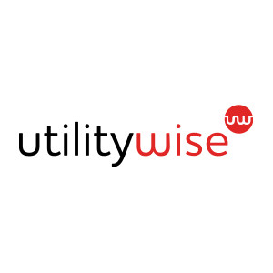
Utilitywise Case Study

Leading Energy Consultants…

_________________________
PROJECT INFORMATION
Construction: All Sectors
Type: Multi unit monitoring
Partners:
Utilitywise
Date completed: 2005 - 2016
Produced by: Madison Gallagher
_________________________
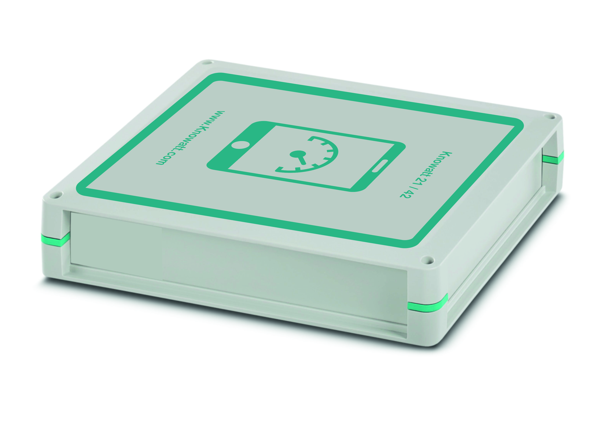

Utilitywise was a British energy consultancy company based in Tyne and Wear, United Kingdom. The business had operations across the UK at their North Tyneside base, Redditch, Bury St Edmonds, Portsmouth and Leicester, as well as 150 staff in the Czech Republic.
They quickly became one of the UK’s leading Energy Consultancy firms with customers based around the globe. Suppling all sectors including Domestic, Industrial and Commercial buildings.

Knowatt was commissioned by Utilitywise to design a monitoring solution with unrivalled accuracy to be given as an incentive to customers as a way of showing they can reduce your costs by helping the customer reduce their usage.

Knowatt was re-commissioned years later to redevelop a further design that could also be installed in Industrial buildings to include varies means of communication and data processing along with control.

