
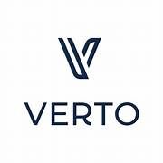
Verto Homes Case Study

Smart Homes for a Smarter Future…

_________________________
PROJECT INFORMATION
Construction: New Build
Type: Smart Homes
Partners:
Verto Homes
Date completed: 2022
Produced by: Madison Gallagher
_________________________
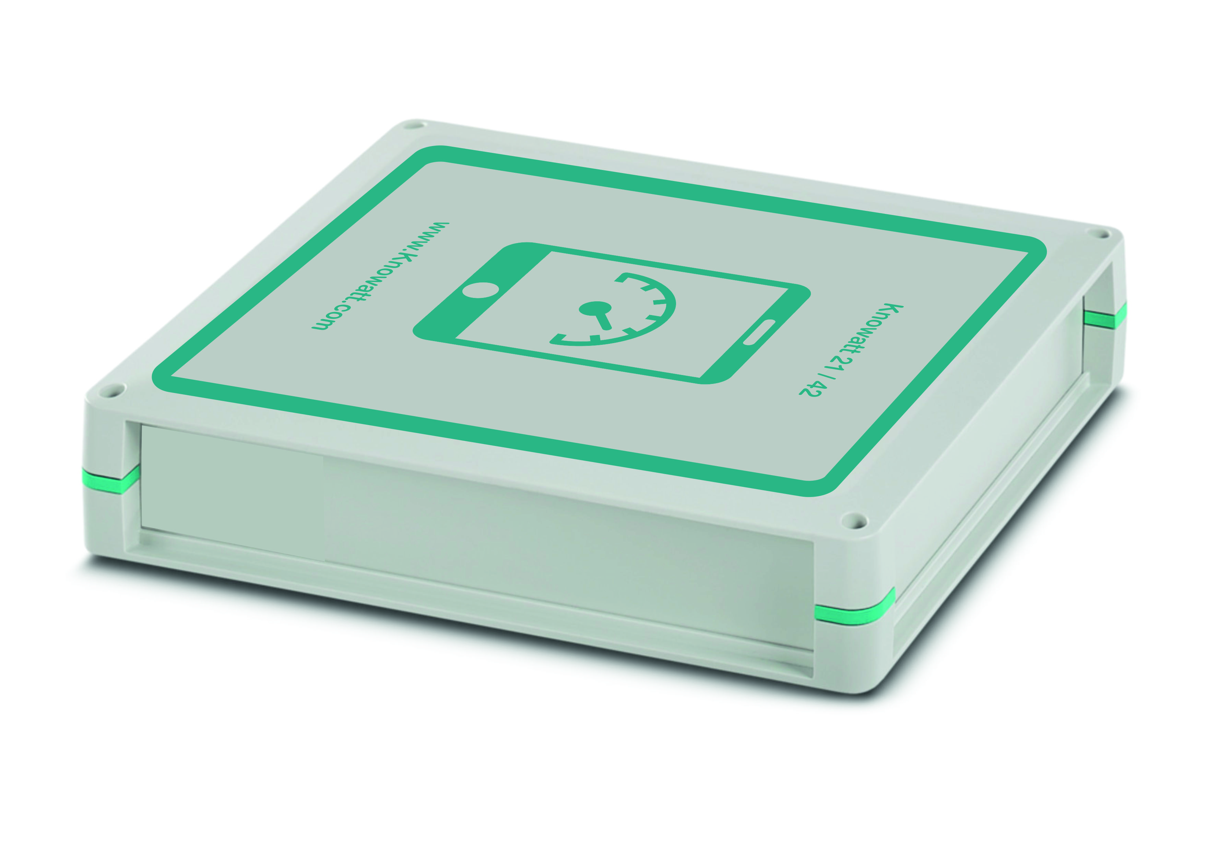
Verto is a business born out of passion for great design, technology and wellbeing. But above all we’re passionate about sustainability.
From the start, Verto’s goal has always been to connect these things which matter to us most and bring them all together in the homes we build.

By doing that, by creating homes which are radically different to the average
new build – We’ve found a way to make a real difference in people’s lives.
And have a real positive impact on the planet.
Founded in 2010, they are the UK’s leading sustainable housebuilder. Only designing, building and selling homes that produce zero carbon emissions — Constantly seeking innovative new materials and technologies which offer the highest levels of energy efficiency.

The solution Knowatt provides.

Verto Homes was excited to include the solution provided by Knowatt to their already exclusive, technology rich offering.
Verto Homes include the latest range of energy saving and smart features throughout the design of their new build homes, allowing for zero emissions using the latest renewable sources available.

A large focus for the Knowatt system was to be able to prove exactly how efficient each source was to the overall consumption from the dwelling and look at which technology provided the greatest impact.
Using the valuable data provided simple automated changes to settings to generate further savings.

Monitoring HVAC, HMRV, Solar PV, Solar Thermal, GSHP, ASHP, Insulation temperature gradients, Water and Export is a simple task for the Knowatt systems in turn providing valuable information and assurance that renewable technology throughout a Smart Home is the key to a smart future.

The only way to prove efficiency and savings made by installed technologies and meters is to monitor these at a minute data collection level.
This data would enable not only Verto homes to prove technology efficiency but also provide home owners to understand their own habits and how they can further reduce usage.

